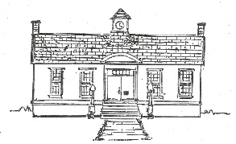
Castleton Free Library Donation FAQs

The Castleton Free Library accepts donations year round. Please call the library before bringing in donations and PLEASE DO NOT drop them in the book drops…. Thank you!

The Library does not accept the following types of donations:
- Dictionaries
- Encyclopedias
- Books with highlighter markings or notes in the text
- Musty, moldy or water damaged books
- VHS or Cassette tapes
- Music CDs
- Computer software

Donations are evaluated in this order:
- Add to the circulating collection.
- List on the Library’s Amazon Book Store for sale
- Shelve on our in-house book sale
- Donation given to our Friends group
- Any books not accepted may be given to Goodwill or in the case of damage, mold or any other reason will be recycled.

We do not appraise the value of books.

We will give a receipt for your books but will not affix a value to the donation.

We do take “things” for the Library. Please contact the library in advance for acceptance/non acceptance.

We thank you for thinking of the library for your donation!

